How to flash both bootloader of Arduino MEGA 2560

Tools:
- Linux Ubuntu 14.04 x64
- Arduino IDE incl. avrdude
- USBasp adapter (CHINA)
- 10 pin to 6 pin cable

Adjustments:
create new file in case can't read USBasp device

- get hex files from github
- copy to ~/.arduino/
- go to directory ~/.arduino/
- connect the 10pin to 6 pin according to following picture and tho the pins next to the wanted atmelchip
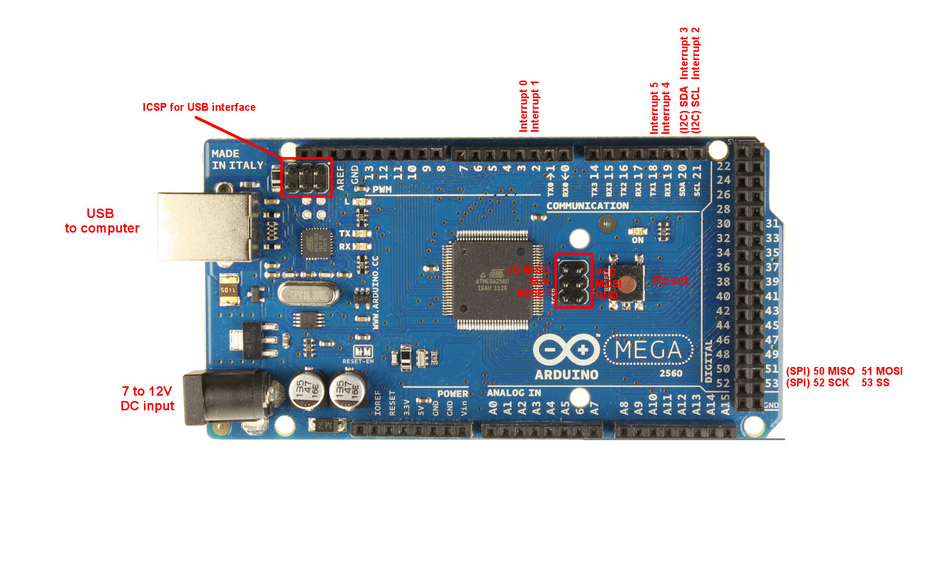

- when connected to dfu chip
$ avrdude -c usbasp -p ATmega16U2 -F -U flash:w:MEGA-dfu_and_usbserial_combined.hex

- when connected to main chip
$ avrdude -c usbasp -p ATmega2560 -F -U flash:w:MEGA-Bootloader.hex

expected result:
avrdude: warning: cannot set sck period. please check for usbasp firmware update.
avrdude: AVR device initialized and ready to accept instructions
Reading | ################################################## | 100% 0.00s
avrdude: Device signature = 0x1e9489
avrdude: NOTE: FLASH memory has been specified, an erase cycle will be performed
To disable this feature, specify the -D option.
avrdude: current erase-rewrite cycle count is -231 (if being tracked)
avrdude: erasing chip
avrdude: warning: cannot set sck period. please check for usbasp firmware update.
avrdude: reading input file "MEGA-dfu_and_usbserial_combined.hex"
avrdude: input file MEGA-dfu_and_usbserial_combined.hex auto detected as Intel Hex
avrdude: writing flash (7452 bytes):
Writing | ################################################## | 100% 3.79s
avrdude: 7452 bytes of flash written
avrdude: verifying flash memory against MEGA-dfu_and_usbserial_combined.hex:
avrdude: load data flash data from input file MEGA-dfu_and_usbserial_combined.hex:
avrdude: input file MEGA-dfu_and_usbserial_combined.hex auto detected as Intel Hex
avrdude: input file MEGA-dfu_and_usbserial_combined.hex contains 7452 bytes
avrdude: reading on-chip flash data:
Reading | ################################################## | 100% 2.53s
avrdude: verifying ...
avrdude: 7452 bytes of flash verified
avrdude: safemode: Fuses OK
avrdude done. Thank you.

